The Pledge – Child healthy weight matters to me
Social Media Toolkit

Twitter Thread with images (save images to your desktop before uploading them in your post!)

1.
🗣️ Child Healthy Weight #MattersToMe❕

📢We're supporting The Pledge & calling on our leaders to deliver on their commitments to children's health.

Urgent action is needed if Scot Gov is to be successful in its ambition of halving childhood obesity by 2030⏳
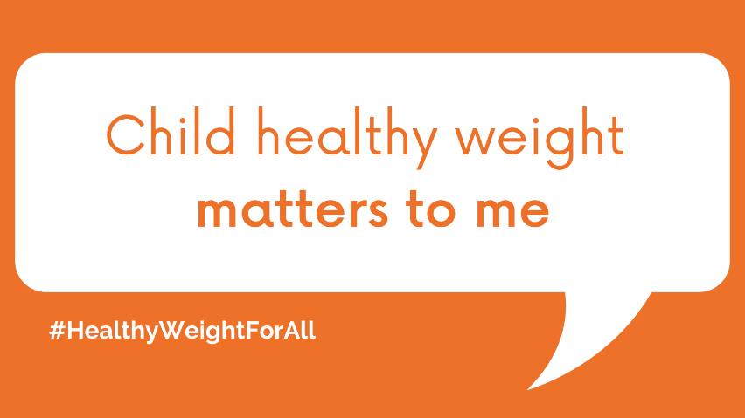

2.
The Scot Gov's Diet & Healthy Weight Delivery Plan includes useful targets & effective policy proposals to improve children's health✅

But implementation of the plan has been limited & levels of healthy weight in children have been dropping✋

👉 bit.ly/3ZT4f4b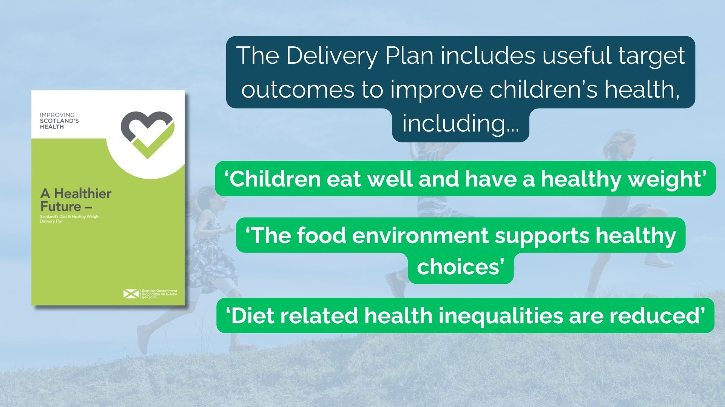

3.
The Pledge campaign is aiming to raise awareness of this inaction & highlight demand for change from the many groups invested in children's health👊🏴󠁧󠁢󠁳󠁣󠁴󠁿

To find out how you can get involved & show your support, visit @obesityactionsc's campaign page🤝

👉 bit.ly/46vDwNj
